Setting up Application Environment Create Flask Project

|  |  |
| --- | --- |
| Team ID | PNT2022TMID04806 |
| Project Name | Personal Expense Tracker Application |

**Step 1.** Install Python latest version from python.org

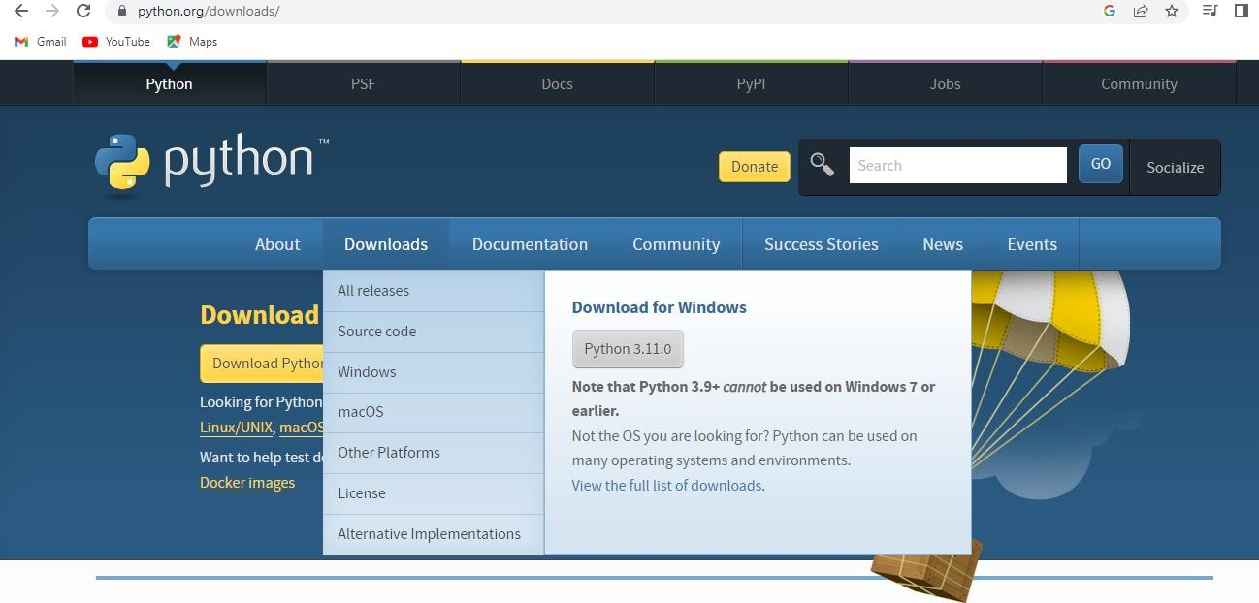

**Step 2**. Download Anaconda from [https://www.anaconda.com/ a](https://www.anaconda.com/)nd install it by running the .exe file

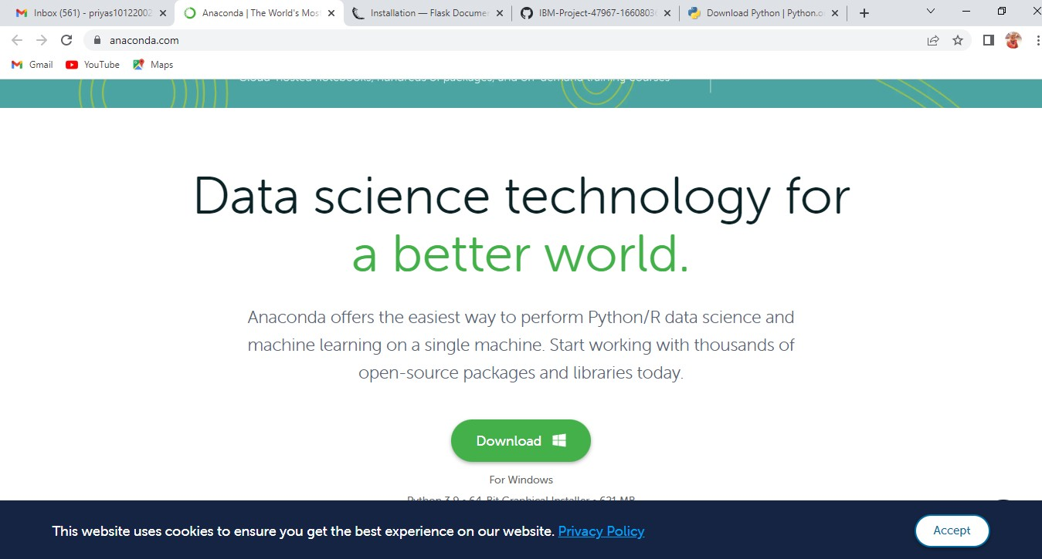

**Step 3**.Install Flask using command pip install flask

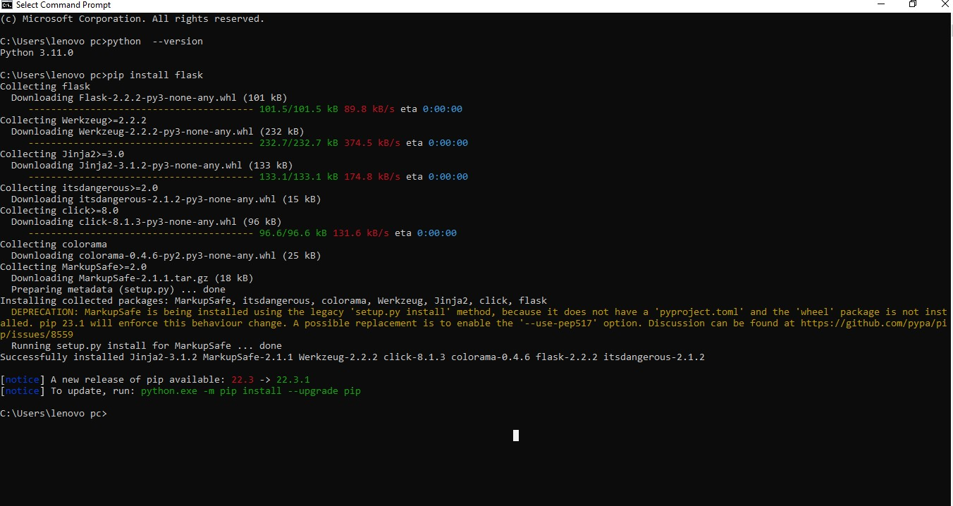

**Step 4**.Open a new Python file and start coding from flask import Flask

app = Flask( name ) @app.route('/')

def hello():

return “Hello World” if name == ' main ':

app.run(debug=True)

**Step 5**. Run the Python file using command python filename.py

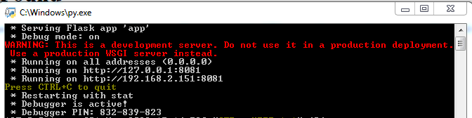

**Step 6**: Open the Ip in browser

